Equipment List

What Guide Dogs provide:
1. Food
2. Preventative Medicine – NexGard Spectra
3. Feed Bowl
4. Collars – puppy, adult, and martingale
5. Leash
6. Longline
7. Brush
8. KongTM
9. Travel Crate
10. Crate

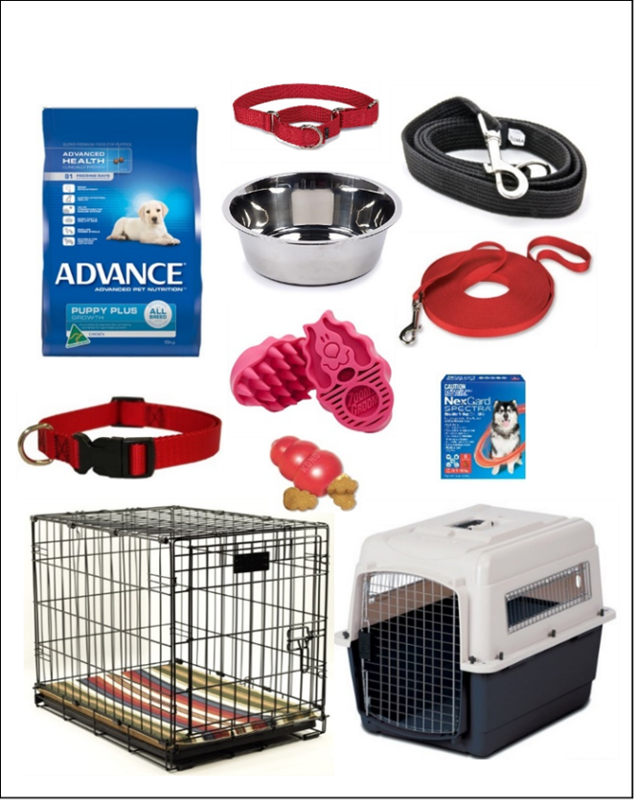

What we ask you to provide:
1. A loving home!
2. Bed
3. Toys from our Approved Toy List
4. Water Bowl – ceramic bowl is often best

