Crate Acceptance
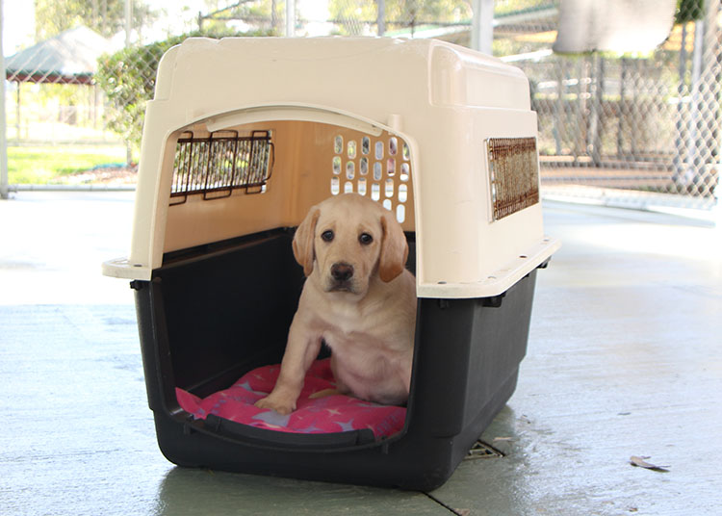

What is Crate Acceptance?
Crate Acceptance is shown when your pup is relaxed and quiet and does not eliminate when confined in a crate:
- Regardless of type.
- Despite location.
- For varied lengths of time.
- With or without people or other dogs present.

A relaxed pup is one that enters the crate readily on the cue “Kennel” and settles quickly without whining, barking or pawing to get out. The goal is that the pup considers the crate his bed.

Why Teach Crate Acceptance?
Crate Acceptance prepares a pup for the inevitable times that they must be left alone. It helps to teach them independence and to stay in one spot quietly and calmly. Teaching Crate Acceptance will also allow the pup to remain more relaxed and less stressed when placed in other areas of confinement. For example, during veterinary stays, and during Guide Dog Training when dogs await in vans for their turn to train.
In addition, the crate can provide the pup with a safe area that they can retreat to if they wish to rest, or alternatively a quiet area where the pup can be directed to go to if he becomes overstimulated, or if he is unable to be supervised for short periods of time (less than 2 hours).
If the pup is misbehaving and redirection has not worked, the crate can be used to give the pup some time out to reflect (reflection time). In this circumstance, after few minutes of reflection, the pup should be released and given the opportunity to behave appropriately.
Puppy Raisers may crate their pup only when they are at home. Crating time must not exceed a period of 2 hours in one crating, and no more than 4 hours in any given day.

How to Teach Crate Acceptance:
At placement time, most pups have reached a comfort level with being crated alone in both plastic and wire crates. Your pup has been exposed to a large amount of crate time, beginning at an early age and progressing gradually in small doses. The crating experience has included particular items that make the crate a familiar and comfortable place for your pup. We call these items the Crating Comfort Kit. Using the Comfort Kit will help make transition to crating in your home a positive experience.
The Comfort Kit should include:
- Soft fleece bedding.
- Chewing toy such as a Nylabone™ or Kong™ that you can stuff with goodies, or leave unstuffed, depending on the situation.
When your pup arrives, begin crating him for short periods of time, starting with 5-10 minutes and working up to 2 hours, both with people in and out of the room, and supported by kibble being dropped intermittently into the crate.
- Be sure that your pup has eliminated before putting him into the crate (see Quick Quick).
- Set up the Comfort Kit in your pup’s crate.
- Toss a few pieces of kibble into the crate through the open door while the pup is watching. This will prompt the pup to enter the crate.
- Say “Kennel”, smile, and praise the pup as he enters the crate. Close the crate door once he is in.
- Initially, stay near the crate, rewarding the pup when he is quiet and settled by dropping 2-3 pieces of kibble into the back of the crate – through the side holes of a plastic crate or the top of a wire crate.
- Calmly take several steps away from the crate without interacting with the pup. Return, rewarding and praising as long as he remains calm and quiet.
- Keep your body language and voice calm and quiet with your praise. You do not want to appear too exciting when you return, as this may encourage your pup to think that your return is better than calmly accepting the crate.
- Gradually increase the amount of time that you are away from the crate to a few minutes, and then return, rewarding the pup for being quiet and settled.
- Steadily decrease the frequency of rewards depending on your pup’s level of settling, and begin leaving the room for short periods of time.
- Only return to the room when the pup is quiet (for around the count of 5 initially); then wait longer as the pup improves. Upon returning, reward with 2-3 pieces of kibble dropped into the back of the crate, then leave again.
- Release your pup from the crate only when he is quiet, sitting calmly, and not pawing, climbing, barking, or whining. If the pup is not sitting, cue him to Sit. Open the door slowly and release the pup with a quiet “Free”. Release from the crate is his real-life reward.
- Keep your demeanour casual after the pup has exited the crate. We do not want the pup to think that all the fun happens once released from the crate. We want to reward the pup’s time in the crate rather than his exit from the crate.
- Work up to 2 hours alone in the crate.

Crating Tips
- Provide exercise for your pup before crating time.
- Have the Comfort Kit in the crate, including the chew toy such as a Nylabone™ or Kong™.
- You can leave a radio or television on so the pup is able to hear some sound in the house.
- Water does not need to be provided for your pup in the crate. However, if it is an extremely hot day, or the pup is under veterinary care, please provide water.
- Practice leaving your pup in his crate in rooms other than the one you are in while you are at home so that he has a chance to build his independence and get used to being in the crate alone for longer periods of time.
- If the pup has been crated for over an hour, provide exercise for your pup following his release.
- A pup should not have two long (2 hours) consecutive crating sessions. The pup must be given at least an hour out of the crate, and be given the opportunity to eliminate and exercise during this time.
- Practice crating the pup away from your home as well as at home.

What Success looks like:
Your pup remains quiet in his crate whether chewing on a toy, napping, or merely observing activity outside the crate. He does not exhibit any signs of frustration such as whining, barking, pawing, panting, shifting positions often, or standing for a prolonged period of time.

Problem Solving
- Your pup is distressed. The signs that a pup is distressed include:
  - Unwillingness to take a food treat.
  - Repetitive, unproductive movements (continual pawing at only one section of the crate versus moving around the entire crate).
  - Actions are not interruptible – the pup continues the behaviour even if you move closer.
  - If your pup is displaying these behaviours, remove your pup from the crate and contact your Puppy Development Adviser for help.
- Your pup eliminates in the crate.
  - Ensure that your pup has had a chance to eliminate prior to placing him in his crate.
  - Do not leave him in the crate for too long. Remember to adhere to the pup’s toilet training schedule. For example, a 9 week old pup that is on a toileting schedule of every 60 minutes cannot be expected to stay in the crate and ‘hold on’ for longer than this period.
  - If the pup is showing signs of needing to eliminate, remove the pup from the crate and take it to “Quick Quick” in the chosen toileting area. Stay in one spot and do not play with the pup. This will avoid him learning that he can get you to go outside to play by demanding your attention. Following elimination, return the pup to the crate for a few minutes before releasing him.
- Your pup vocalises (barks, whines, whimpers) when in the crate.
  - If your pup is very active, vocalising, and excited, do not go directly to the crate. Give him a few seconds to settle. When he is quiet for a brief period you can praise him and then reward him by dropping in a few treats. Ask him to Sit before letting him out of the crate.
  - In the early stages of learning you may have to lure him into the Sit.
  - If he does not settle, then consider the pup may need to eliminate. Take him out to “Quick Quick” immediately. Once your pup has eliminated, return him to the crate and practice his crate exit as outlined above.
  - Practice shorter times in the crate so that he can learn how to control himself when people are coming and going. You can do this by inviting friends and neighbours to drop in to aide with his learning.

- Your pup is chewing on the fleece.
  - Remove the fleece mat from the crate so that he cannot chew on it. With some pups the fleece will not be a viable bedding option. That is okay. It is better to have a safe pup than a sick pup.

Key Points
- Practice Crate Acceptance in multiple sessions throughout the day and in various locations in and away from your home.
- A pup learns that quiet calm behaviour while in the crate is rewarded by your return, occasional food treats, and exiting the crate.
- Using a casual voice, release your pup by asking him to Sit, open the crate door, and release him from the Sit with the cue Free.
- Reward the pup’s time in the crate rather than making the exit seem exciting and rewarding.
- When crated, ensure that it is a safe area for the pup, and that he will not be interrupted by children or other pets.

Crate Acceptance is a skill that should be practiced throughout your pup’s time with you. By 8 months, the pup should be able to be left crated for up to 2 hours without vocalising or showing any signs of stress. In addition, independent, unsupervised time in the house where the pup is not crated should be without incidence of destructive or unfavourable behaviour. It is at this time that the crate can be returned to the Guide Dogs Centre.

