Approved Treats Policy

Dog Treats: Commercial treats and chewable bones
Most dog treats are very high in salt, fat and preservatives. They can be a cause of imbalance in the immature gastrointestinal tract, often resulting in diarrhoea and vomiting in young dogs. In addition, items like rawhides, deer antlers, and bones can cause obstructions in the bowel, and even cause teeth to fracture. As such, not only do many treats cause harm to our pups, but they are a major component of our external veterinary bills. After much discussion around the impact that these treats have on the immature gastrointestinal tract of our dogs, Guide Dogs has introduced a Dog Food and Treat Policy. Please refer to the table below for approved treats and amounts which can be fed.

Approved Dog food: Advance Puppy/Adult Dog
We feed all our puppies and adult dogs Advance dog food dry, wet and dry formulations. It is a premium quality pet food which has been formulated to meet the nutritional requirements of growing and working dogs. It provides a careful combination of proteins, fats, minerals, vitamins, carbohydrates and water to create a complete and balanced diet.

Prescription diets
Some of our dogs may be placed on prescription dietary trials if they are showing symptoms of skin or gastrointestinal allergies. These are generally short term trials (4-6 weeks) and during this time period the puppy or dog may not be given any food outside of the prescription diet i.e., these animals cannot even be given any of the food items listed in the below table.

Treat allowance
To ensure that our pups and dogs maintain a healthy body weight, any food treats given must be taken from their daily feed amount. Treats and additional food items should not exceed 10% of daily food intake. The majority (90% or greater) of the calories should come from Advance dog food as recommended by Guide Dogs. These food types are to be used as high value treats, and, ideally only one food type should be fed in any given day.

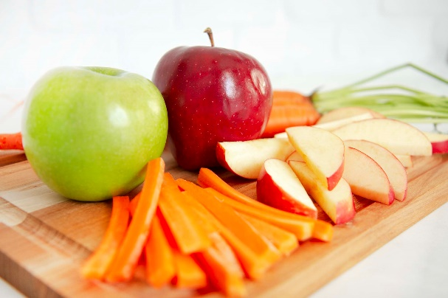

See next page for daily treat allowances.
Food Type | Daily Allowance | Qty kibble to be removed from daily food ration | Notes
Prime 100, cooked meat and vegetable rolls | ¼ cup | ¼ cup | - Any of the cooked variety rolls are acceptable  - It can be purchased from most retail pet stores.  - Must be kept refrigerated.  - It can be chopped up and stored in the freezer in zip-lock bags ready for a training session.  - Use a permanent marker to date the bags, and store for up to 3 months in the freezer
Chicken Breast (cooked) | ¼ cup | ¼ cup | - Chicken can be cooked, cooled, chopped up, and then (like the Roll), stored in the freezer for up to 3 months.  - Ensure only clean utensils are used for the cooked meat.
Carrot | 1 carrot | - | - Carrot can be chopped up and used as training treats or delivered whole as an enrichment item.  - Circular pieces can be strung onto twine and hung between a door frame for supervised enrichment
Apple | ½ apple | - | - Apple can be chopped up and used as training treats or put in enrichment items like KongsTM.
Pear | ½ pear | - | - Pear can be chopped up and used as training treats or put in enrichment items like KongsTM.
Zucchini | 3/4 of a cup, cubed | - | - Cooked  - Zucchini can be chopped up and used as training treats or put in enrichment items like KongsTM.
Butternut pumpkin | ¼ cup, cubed | - | - Cooked  - Butternut Pumpkin can be chopped up and used as training treats
Banana | 1/8 cup, mashed | - | - Banana can be mashed into a Kong^{TM.}  - Ensure KongTM is thoroughly cleaned and washed afterwards

