Dog Park and Off-Leash Policy
Dog Parks and Off-leash Policy
Good socialisation of our pups with other dogs is essential to developing good social skills and confidence. It is important for a Guide Dog to be able to understand the body language of other dogs and respond appropriately. This is achieved through repeated positive dog to dog interactions, including off-leash play, with carefully considered playmates.
There is inherent risk using public off-leash areas however and the welfare and safety of our pups and dogs is paramount. Public off-leash dog areas involve our dogs socialising with other dogs of unknown health status, temperament, and dog-dog social skills, especially at peak times. Pups and dogs can become traumatised by other dogs in these environments and a negative incident can result in increased dog reactivity. Injury, illness, and death are also risks.
As such, the use of dog parks, dog friendly beaches, nature walks, and off- leash areas, is considered on a case-by-case basis and only after a pup has reached 5 months of age. Puppy Raisers wishing to utilise these spaces must seek permission from their Puppy Development Adviser and read the following guidelines prior to attending any off-leash spaces.
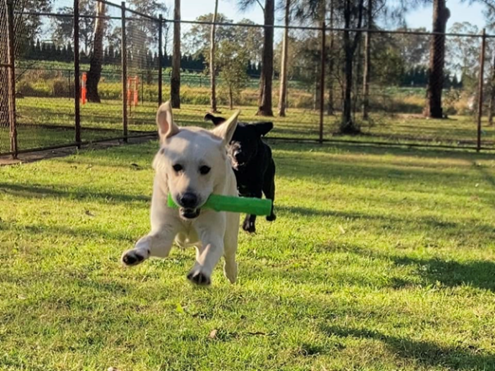

Your Puppy Development Advisor will consider:
  - Completion of Foundation classes.
  - Completion of Education Sessions 1 and 2.
  - Safety of off-leash area the Puppy Raiser wishes to visit.
  - Puppy Raiser skill at assessing risk of off-leash area.
  - Pup/dog demonstrated ability to appropriately socialise with other dogs (age appropriate).
  - Puppy Raiser skill at reading dog body language and stress cues.
  - Puppy Raiser and pup/dog team recall skills.
  - Likelihood of pup/dog enjoying and benefitting from off leash areas.
It should be noted that your Puppy Development Advisor may decline your request based on the welfare of the pup/dog. Your Puppy Development Advisor or other trained staff at Guide Dogs may also temporarily or permanently cease off-leash area permission for your dog even after permission is granted. This will be based on careful consideration of your dog’s temperament and behaviour, or stage of training i.e., if your dog begins to display fear behaviour with other dogs on lead, then it will not be appropriate to continue to take your dog to an off-leash area, or, if your dog is nearing Guide Dog client placement, to reduce risk of injury, you may be asked to not attend off-leash areas where other dogs are present, etc. Decisions are always made with your dog’s welfare and comfort at front of mind.
It is also important to acknowledge that not all dogs enjoy dog off lead areas. Many alternative locations exist that may facilitate fun dog to dog interactions including fenced in yards, tennis courts, or even in larger fully fenced fields. Puppy playdates with known dogs is a great way for your dog to learn social cues and manners.
How Do I Know if an Off-leash Area is Safe?
The honest answer is – you can’t always know. This is why there is inherent risk to off-leash areas. To make the best educated decision however please adhere to the following guidelines to reduce risk:
  - Off-leash dog parks and areas should be enclosed, or large enough that a dog is not at risk of running into traffic or public spaces.
  - Off -leash dogs parks should first be surveyed before entering. Please do not enter if you observe:
- Dogs showing signs of aggression or poor social skills.
- Unkempt i.e., rubbish, broken items, dog faeces, etc.
- Long un-mowed grass.
- Dogs standing by owners cowering, hiding, or growling.
- Dog owners distracted in conversation or staring at phones and not watching their dogs carefully.
  - Where possible tip water out of shared water bowls, rinse, and refill to reduce risk of communicable illness and disease such as gastro bugs and canine cough.
  - If you are in the dog park and dogs enter who display poor social skills, leave immediately.
  - If your dog becomes over stimulated and seeks out other dogs to continually chase or hump, put your dog back on lead and allow some cool down time, then release. If your dog continues, it’s time to leave. We do not want your dog to practice undesirable behaviours. Please seek advice from your Puppy Development Advisor who can assist with managing these behaviours.
  - Always wear your treat pouch when visiting off-leash areas. Take high value treats. Ensure your recall is reliable. This is the perfect place to practice!
  - Choose off peak times. The busier the park, the higher the risk.
  - Ensure your dog is on leash until you are safely in the off-leash area.
  - For nature walks consider using longline leads to mitigate risk of being lost or injured. Please do not use retractable leads.
  - For off-leash beach areas please use the same precautions that you would for a park where possible. Keep your dog on lead until you are securely in the beach area.
  - When utilising public areas, ensure that you are complying with all local council regulations and always maintain control of your pup/dog. Please note that should you incur a notice for not being compliant with regulations or willingly enter a private property, Guide Dogs will not be responsible for any consequences incurred.

Entire (un-desexed) Dogs in Off -Leash Areas
Your pup will likely not be desexed until after 12 months of age. As such it is important that the hormonal changes in your dog are considered when taking your dog to off-leash areas.
Large breed female dogs generally have their first season around 10 – 14 months of age but can come into season from 6 months of age. When female dogs are about to enter a season, they attract attention from male dogs. Your female dog may also feel more sensitive at these times and may become irritated or overwhelmed by the attention. If you suspect your female dog is coming into season, immediately cease from visiting any off-leash areas to mitigate the risk of unwanted mating and pregnancies and undesired attention from other dogs. Your female dog will thank you!
Entire male dogs become fertile at around 6 months of age. As such, it is imperative that you keep a close watch on entire males when mixing with other dogs to ensure that an accidental pregnancy does not occur.
Your pup/dog must remain on leash at all other times when outside of an off-leash area.

Mounting and Humping Behaviour
Mounting and humping behaviour is normal for dogs, albeit at times a little embarrassing! Mounting is a pre-programmed behaviour that most dogs are born with. This is called a fixed action pattern (FAP). These FAPs are triggered by the dog’s environment without any prior learning. This is why you see young puppies displaying this behaviour like an old pro!
It is usually not appreciated by other dogs either who can become quickly agitated when another dog mounts them. Dogs mount toys, pillows, other dogs, and people. Mounting is an early part of communication development in young puppies and is often seen in play. It can increase in frequency and intensity as the dog approaches sexual maturity and can easily turn into an attention seeking behaviour by both male and female dogs.
Mounting behaviour is triggered by many factors including play, excitement, conflict/stress, or general arousal. Triggers such as play (with humans and other dogs) and excitement e.g., when someone arrives home, can lead to mounting behaviour being displayed. Mounting can also occur in conflict situations that cause mild frustration or anxiety – settings where a dog wants to do something, but isn’t allowed to, and funnels the energy into an unrelated behaviour.

How do I Manage a Mounting Dog?

Interrupt and redirect
Prevention is the best method of managing mounting. If you know when the behaviour usually occurs (e.g., the triggers), help your puppy or dog to be calm in these situations and give them something to do (such as a chew) to bring their excitement level down. You should also teach the dog reliable recall skills to call your dog away from other dogs or items.
If you find it problematic (it is usually considered problematic when mounting is displayed to humans or other dogs), then teach an alternative behaviour such as ‘off’ or ‘leave it’. Try to cue your dog or puppy to do this before they get too excited. Using a tug toy can distract a puppy or dog and focus their attention on playing with you more appropriately. Using an excited voice to catch their attention whilst walking away is another. Use ‘timeout’ to teach your dog or puppy that engaging in mounting behaviour results in no social contact for a short period (no longer than 30 seconds otherwise they’ll forget why they are in timeout!). This could mean popping them on lead and walking away from the excitement. They do not need to be isolated.
It is far easier to prevent the behaviour than to interrupt it! In the situations where you see the mounting behaviour, be prepared to step in and distract your dog to help reduce its excitement level.

What to do in the case of a dog attack/bite
  - Remove yourself and your dog from the area immediately.
  - Check your dog over and attend to any concerns that you are able to i.e. if your dog is bleeding apply pressure to the area, etc.
  - Take your dog to an Approved Vet for a check-up immediately. Internal damage is not always obvious externally.
  - Where possible and only if safe to do so, take details of the person responsible for the dog who attacked.
  - Report to your Puppy Development Advisor or the Guide Dog Centre as soon as possible.

